Project Planning Phase
Project Planning Template (Product Backlog, Sprint Planning, Stories, Story points)

Date | 30 September 2026
Team ID | SWTID-2026-2617
Project Name | Streamlining IT Procurement: Automating Standard Laptop Orders with Flow Designer
Team Size | 4
Team Leader | Goushikram G
Team Members | Santhosh Karthick A  Jason Selvin Raj J  Abutharick M
Maximum Marks | 5 Marks

Product Backlog, Sprint Schedule, and Estimation (4 Marks)
Use the below template to create product backlog and sprint schedule
Sprint | Functional Requirement (Epic) | User Story Number | User Story / Task | Story Points | Priority | Team Members
Sprint-1 | Service Catalog Ordering | USN-1 | As an employee, I can browse Service Catalog > Hardware and open the Standard Laptop item to see its specifications and price. | 2 | High | Santhosh Karthick A
Sprint-1 | Service Catalog Ordering | USN-2 | As an employee, I can place an order for a Standard Laptop using Order Now. | 2 | High | Santhosh Karthick A
Sprint-1 | Flow Automation | USN-6 | As a member of the IT procurement team, I want a flow with a Service Catalog trigger so that standard laptop orders start the process automatically. | 3 | High | Goushikram G
Sprint-1 | Flow Assignment | USN-9 | As an administrator, I can attach the flow to the Standard Laptop catalog item using the Process Engine. | 3 | High | Jason Selvin Raj J
Sprint-2 | Request Tracking | USN-3 | As an employee, I can open my request and requested item to track its status. | 2 | Medium | Santhosh Karthick A
Sprint-2 | Request Approval | USN-4 | As an approver, I can open the Approvers section of the request and approve it. | 3 | High | Jason Selvin Raj J
Sprint-2 | Request Approval | USN-5 | As an approver, I can reject a request that should not be fulfilled. | 2 | Medium | Jason Selvin Raj J
Sprint-2 | Catalog Task Creation | USN-7 | As a member of the IT procurement team, I want a catalog task created automatically after the order is approved so that no manual intervention is needed. | 5 | High | Goushikram G
Sprint-2 | Laptop Configuration | USN-8 | As a hardware team member, I can see the catalog task assigned to the Hardware group so that I can configure the laptop promptly when it arrives. | 2 | High | Abutharick M
Sprint-3 | Flow Configuration | USN-10 | As an administrator, I can run the flow as System User in the Global application so that tasks are always created. | 3 | Medium | Abutharick M

Project Tracker, Velocity & Burndown Chart: (4 Marks)
Sprint | Total Story Points | Duration | Sprint Start Date | Sprint End Date (Planned) | Story Points Completed (as on Planned End Date) | Sprint Release Date (Actual)
Sprint-1 | 10 | 6 Days | 05 Oct 2026 | 10 Oct 2026
Sprint-2 | 14 | 6 Days | 12 Oct 2026 | 17 Oct 2026
Sprint-3 | 3 | 6 Days | 19 Oct 2026 | 24 Oct 2026

Velocity:
Story points are estimated on the scale 1, 2, 3, 5 (very easy to difficult). Total story points = 10 + 14 + 3 = 27 across 3 sprints, so the team velocity = 27 / 3 = 9 story points per sprint. With a sprint duration of 6 days, the average velocity per day (AV) = 9 / 6 = 1.5 story points per day.

Burndown Chart:
A burn down chart is a graphical representation of work left to do versus time. It is often used in agile software development methodologies such as Scrum. However, burn down charts can be applied to any project containing measurable progress over time.

The chart shows the planned burndown. Update it with the story points actually completed at the end of each sprint.
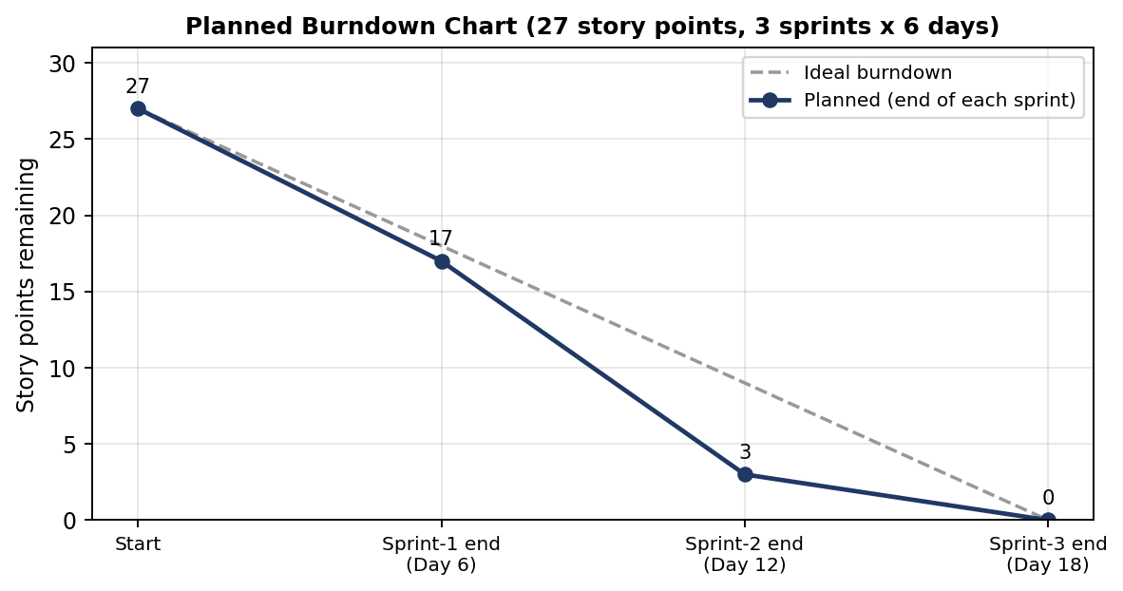

https://www.visual-paradigm.com/scrum/scrum-burndown-chart/
https://www.atlassian.com/agile/tutorials/burndown-charts

Reference:
https://www.atlassian.com/agile/project-management
https://www.atlassian.com/agile/tutorials/how-to-do-scrum-with-jira-software
https://www.atlassian.com/agile/tutorials/epics
https://www.atlassian.com/agile/tutorials/sprints
https://www.atlassian.com/agile/project-management/estimation
https://www.atlassian.com/agile/tutorials/burndown-charts

